# Algorithm for file updates in Python

## Project description

At my organization, there is an allow list (allow_list.txt)for IP addresses permitted to sign in to restricted content and there is also a remove list that identifies which employees should be removed from the allow list.

I was tasked with creating an algorithm to check whether the allow list contains any IP addresses identified on the remove list and remove those IP addresses from the file containing the allow list.

## Open the file that contains the allow list

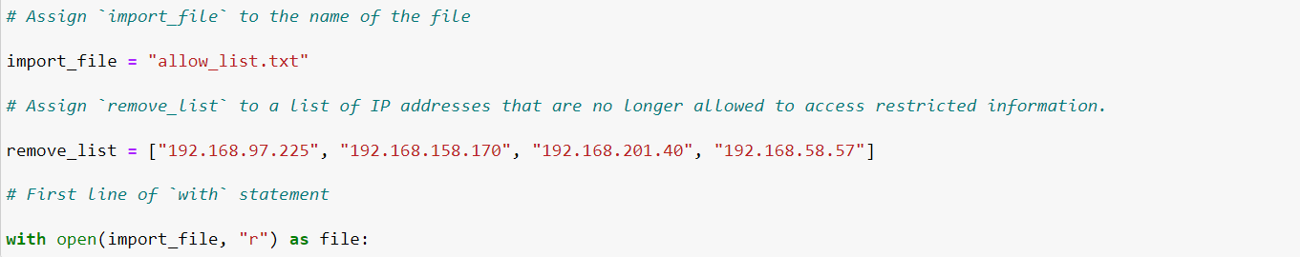

First I assigned the file name allow_list.txt as a string to the variable import_file. I then used a with statement to open the file. In my algorithm, the with statement is used with the .open() function in read mode to open the allow list file for the purpose of reading it. In the code with open(import_file, "r") as file:, the open() function has two parameters. The first identifies the file to import, and then the second indicates what I want to do with the file. In this case, "r" indicates that I want to read it. The code also uses the as keyword to assign a variable named file; file stores the output of the .open() function while I work within the with statement.

## Read the file contents

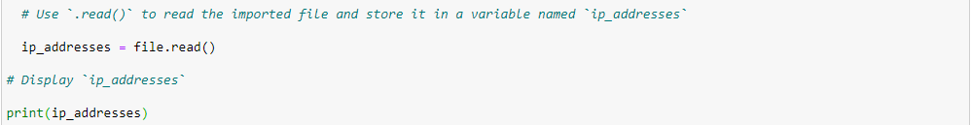

I used the .read() method to convert it into the string. The .read() method converts the file into a string and allows me to read it. I applied the .read() method to the file variable identified in the with statement. Then, I assigned the string output of this method to the variable ip_addresses. This code reads the contents of the "allow_list.txt" file into a string format that allows me to later use the string to organize and extract data in my Python program.

## Convert the string into a list

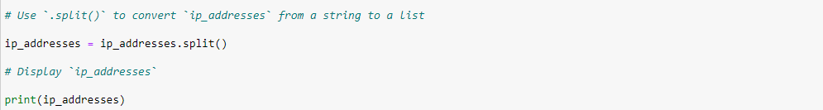

I need it to be in list format in order to remove individual IP addresses from the allow list. I used the .split() method to convert the ip_addresses string into a list. The .split() function takes the data stored in the variable ip_addresses, which is a string of IP addresses that are each separated by a whitespace, and it converts this string into a list of IP addresses. To store this list, I reassigned it back to the variable ip_addresses.

## Iterate through the remove list

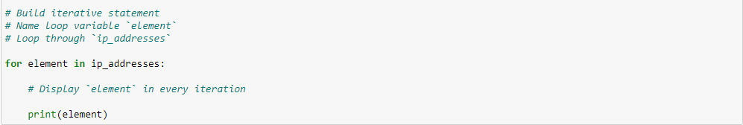

I used a for loop to iterate through the IP addresses that are elements in the remove_list.

## Remove IP addresses that are on the remove list

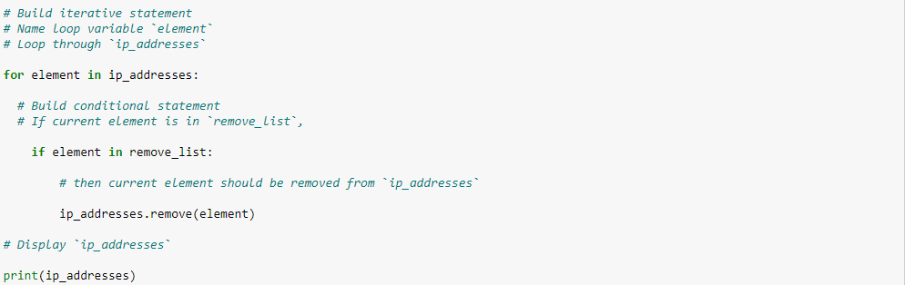

My algorithm needs to remove any IP address from the allow list. Within my for loop, I created a conditional that evaluated whether or not the loop variable element was found in the ip_addresses list. Within that conditional, I applied .remove() to ip_addresses. I passed in the loop variable element as the argument so that each IP address that was in the remove_list would be removed from ip_addresses.

## Update the file with the revised list of IP addresses

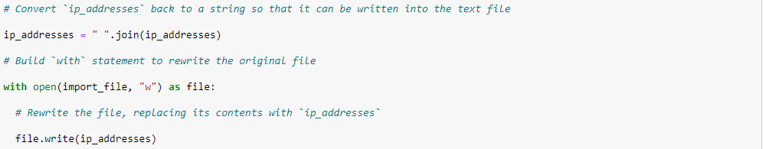

For the final step, I used the .join() method to convert the list back into a string. The .join() method created a string from the list ip_addresses so that I could pass it in as an argument to the .write() method when writing to the file "allow_list.txt". I used another with statement and the .write() method to update the file. I passed in the ip_addresses variable as the argument to specify that the contents of the file specified in the with statement should be replaced with the data in this variable.

## Summary

I developed an algorithm to remove IP addresses listed in the remove_list variable from the allow_list.txt file, which contains approved IP addresses. I began the process by opening the file and reading its contents as a string. I then converted this string into a list, stored in the variable ip_addresses. Next, I iterate through remove_list, checking if each IP address exists in ip_addresses . If found, I use the .remove() method to eliminate it. Once all specified addresses are removed, I convert ip_addresses back into a string using the .join() method and overwrite allow_list.txt with the updated list.